THERMOCHEMISTRY
Thermodynamics is defined as the branch of science that deals with the relationship between heat and other forms of energy, such as work. It is frequently summarized as three laws that describe restrictions on how different forms of energy can be interconverted.
The Laws of Thermodynamics
First law: Energy is conserved; it can be neither created nor destroyed.
Second law: In an isolated system, natural processes are spontaneous when they lead to an increase in disorder, or entropy.
Third law: The entropy of a perfect crystal is zero when the temperature of the crystal is equal to absolute zero (0 K).

Thermochemistry is the portion of thermodynamics that relates to chemical reactions. It is the study of the energy changes taking place during chemical reactions. A reaction may release or absorb energy, and a phase change may do the same, such as in melting and boiling. Thermochemistry focuses on these energy changes, particularly on the system's energy exchange with its surroundings. It is useful in predicting reactant and product quantities throughout the course of a given reaction. By calculating entropy, it is also used to predict whether a reaction is spontaneous or non-spontaneous, favorable or unfavorable.

Energy and Its Units

Energy is the potential or capacity to move the matter. It is not a material thing but rather a property of matter. Energy exists in different forms that can be inter-converted.

In this chapter, we will be concerned with the energy of substances, or chemical energy, and its transformation during chemical reaction into heat energy. To prepare for this, we will first explore the quantitative meaning of the energy of motion (kinetic energy). Then we will look at the concepts of potential energy and of the internal energy of substances, which is defined in terms of the kinetic and potential energies of the particles making up the substance.

Kinetic energy is the energy associated with an object by virtue of its motion. An object of mass m and speed or velocity v has kinetic energy E_{k} equal to

E_{k} = ½ mv²
This formula shows that the kinetic energy of an object depends on both its mass and its speed. A heavy object can move more slowly than a light object and still have the same kinetic energy. The SI unit of energy, kg.m²/s², is given the name Joule (J).

Potential energy is the energy an object has by virtue of its position in a field of force. For example, water at the top of a dam has potential energy (in addition to whatever kinetic energy it may possess), because the water is at a relatively high position in the gravitational force field of the earth. We can calculate this potential energy of the water from the formula:
E_{p} = mgh.
Here E_{p} is the potential energy of a quantity of water at the top of the dam, m is the mass of the water, g is the constant acceleration of gravity, and h is the height of the water measured from some standard level.

The potential energy of the water at the top of the dam is converted to kinetic energy when the water falls to a lower level. As the water falls, it moves more quickly. The potential energy decreases and the kinetic energy increases. The sum of the kinetic and potential energies of the particles making up a substance is referred to as the internal energy, U, of the substance. Therefore, the total energy, E_{tot}, of a quantity of water equals the sum of its kinetic and potential energies as a whole (E_{k} + E_{p}) plus its internal energy.

E_{tot} = E_{k} + E_{p} + U

Law of conservation of energy: ‘Energy may be converted from one form to another, but the total quantity of energy remains constant’.

Enthalpy and Entropy:

Enthalpy is a thermodynamic property of a system. Every substance contains stored chemical energy, called enthalpy, mainly by virtue of chemical bonds. Absolute enthalpy is hard to measure, but enthalpy changes (ΔH) during reactions are easy to measure because there will be an observable energy exchange between the chemicals and the surroundings.
ΔH = ΔE + PΔV
i.e., the change in enthalpy (ΔH) is the sum of the change in the internal energy (ΔE) and the work done (PΔV).

Entropy is another thermodynamic property, which we can consider as a measure of the disorder or randomness of a system. It is defined as
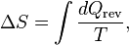

i.e. the change in entropy (ΔS) of a thermodynamically reversible process equals the total heat transferred between the system and its surroundings divided by T. An ordered system has low entropy. A disordered system has high entropy. For example, in solid state molecules strongly attracted (less disorder) and in gaseous state molecules are not strongly attracted (more disorder). Due to that, entropy is greater in a gas.

Enthalpy and entropy are different quantities. Enthalpy has the units of heat, joules. Entropy has the units of heat divided by temperature, Joules per Kelvin.

System, boundary, surrounding and universe

System: The portion of the physical universe, which is under thermodynamic consideration, is called a system. There are three types of system:
Open system : energy & matter can transfer
Closed system : energy transfers only
Isolated system : no transfer

It usually consists of definite amount of a specific substance.

Boundary: The real or imaginary line that marks the limit of the system to a definite place in space is called boundary.

The boundary separates the system from the rest of the universe i.e. the surroundings.

Surrounding: The portion of the physical universe outside the boundary of the system is known as surrounding.

Universe: It consists of a system and a surrounding of that system in space.

Exothermic and Endothermic Systems:
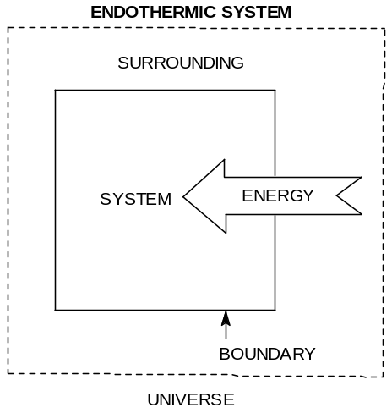
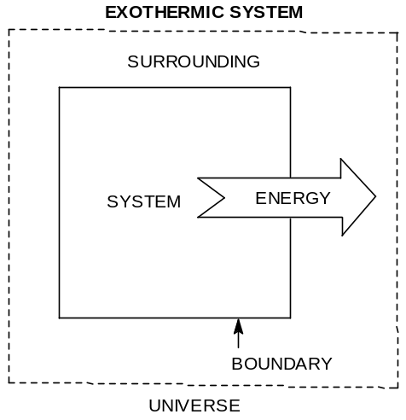

Total energy of a body: All types of energy that a body possesses are known as total energy of a body. There are two main types of energy that a body possesses;

The external energy

The internal energy

Each of these two types can again be sub-divided into- (i) the potential energy and (ii) the kinetic energy.
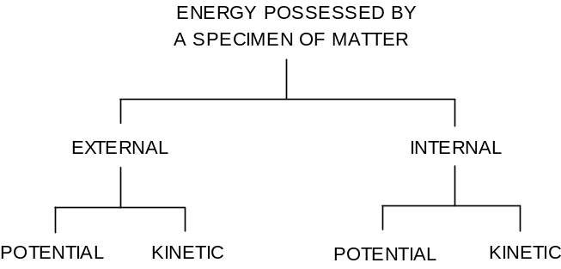

External potential energy: Potential determined by the position of the matter relative to the earths surface or relative to some other reference datum.

External kinetic energy: Kinetic determined by the speed of the movement of the matter.

Internal potential energy: Potential determined by the composition, structure or relative position of the atoms including those of the subatomic particles inside the atom, and/or groups of atoms forming the molecule of the substance. The attractive & repulsive forces acting between the residents of the atoms also contribute to the potential energy of the substance.

Internal kinetic energy: It is due to the motion such as vibrational, rotational or spinning type motion of the molecule, atoms and sub-atomic units of the atom.

HEAT OF REACTION

The amount of heat that is either evolved or absorbed during the course of a chemical reaction (when number of moles of reactants as represented by valanced chemical equation change completely into products) is called ‘heat of reaction’.

Examples:
C (s) + O₂ (g) → CO₂ (g) ; ∆H = - 93.03 Kcal ( -ve heat of reaction, exothermic),
2C (s) + 2H₂ (g) → C₂H₄ (g) ; ∆H = + 12.5 Kcal (+ ve heat of reaction, endothermic),
----------------------------------------------------------------------------------------------------------------
# Heat content of CO₂ is less than the sum of heat contents of C and O₂, and hence heat is evolved.
# Heat of reaction depends on the volume, the pressure, the temperature of the system, the amount and the allotropic form of the reacting substances, also on physical state and products.
----------------------------------------------------------------------------------------------------------------

Types of heat of reaction:

(1) Heat of Combustion, (2) Heat of Formation, (3) Heat of Solution, (4) Heat of Neutralization. [Other form of heat of reactions may arise during phase change or energy changes in the case of fusion, vaporization, sublimation and transition]

- Heat of Combustion
It is defined as the change in enthalpy of a system when one mole of the substance is completely burnt in excess of air or oxygen. Heat of combustion is always negative.Example:
CH₄ (g) + 2O₂ (g) → CO₂ (g) + 2H₂O (l), ∆H_{c} = - 21.0 Kcal

- Heat of Formation
The change in enthalpy that takes place when one mole of the compound is formed from its elements. Example:
2C (s) + H₂ (g) → C₂H₂ (g) ; ∆H_{f} = + 53.14 Kcal

- Heat of Solution
The change in enthalpy when one mole of the substance is dissolved in a specified quantity of solvent at a given temperature. Example:
KCl (s) + H₂O (l) → KCl (aq) ; ∆H_{s} = - 4.4 Kcal

- Heat of Neutralization
It is defined as the change in heat content of the system when one gram equivalent of an acid is neutralized by one gram equivalent of a base or vice versa in dilute solution.
Example:
NaOH (aq) + HCl (aq) → NaCl (aq) + H₂O (l) ; ∆H_{n} = - 13.68 Kcal
Fuels - Foods, Commercial Fuels, and Rocket Fuels

A fuel is any substance that is burned or similarly reacted to provide heat and other forms of energy.

Food as Fuels

Foods ﬁll three needs of the body: they supply substances for the growth and repair of tissue, they supply substances for the synthesis of compounds used in the regulation of body processes, and they supply energy. About 80% of the energy we need is for heat. The rest is used for muscular action, chemical processes, and other body processes.

The body generates energy from food by the same overall process as combustion, so the overall enthalpy change is the same as the heat of combustion.
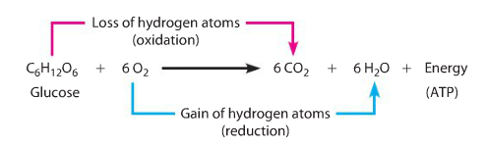

Fossil Fuels

All of the fossil fuels in existence today were created millions of years ago when aquatic plants and animals were buried and compressed by layers of sediment at the bottoms of swamps and seas. Over time this organic matter was converted by bacterial decay and pressure to petroleum (oil), gas, and coal.

The major problem with petroleum and natural gas as fuels is their relative short supply. It has been estimated that petroleum supplies will be 80% depleted by about the year 2030. Natural-gas supplies may be depleted even sooner. Coal supplies, on the other hand, are sufﬁcient to last several more centuries. This abundance has spurred much research into developing commercial methods for converting coal to the more easily handled liquid and gaseous fuels.

Rocket Fuels

Rockets are self-contained missiles propelled by the ejection of gases from an oriﬁce. Usually these are hot gases propelled from the rocket by the reaction of a fuel with an oxidizer.

Nuclear Fission

Large nucleus is bombarded with a neutron, huge heat is produced, can be used to generate electricity, huge nuclear waste (chain reaction).

²³⁵₉₂U + ¹₀n = ²³⁶₉₂U followed by ²³⁶₉₂U = ¹⁴⁴₅₆Ba + ⁸⁹ ₃₆Kr + 3¹₀n + 177 MeV

Nuclear Fusion

Deuterium-tritium fusion produces very high temperature, heat energy more than fission, very difficult to control, no waste.

² ₁Deuterium + ³ ₁Tritium = ⁴₂He + ¹₀n + 17.6 MeV

